15CSE376 Net Centric Programming

Review Term: 1

Group Number: 12

Project Title: Alumni Portal

|  |  |
| --- | --- |
| Team Members | Roll Numbers |
| Ishwarya .S | CB.EN.U4CSE16423 |
| Lakshmi Priya E | CB.EN.U4CSE16432 |
| Yamini Sanjana | CB.EN.U4CSE16466 |
| Sneha Varsha | CB.EN.U4CSE16467 |

ABSTRACT

Many institutions, colleges and universities maintain the information manually about present and past students. This does not allow efficient data management and retrieval process. A student willing to get information about others has to approach the college and obtain the details. Often the information may not be available and misleading.

The objective of this application is to allow old and new students of a university or college to communicate with each other. This allows students to know about each other and their current activities.

INTRODUCTION TO WEB DESIGNING

Web design is the visual aesthetics and page layout of a website. It goes hand-in-hand with web development in the creation of a static website or dynamic web application.

Even if you don’t consider yourself a creative person, it’s still a good idea to learn web design. No matter whether you want to make static websites or dynamic web applications, design is an important part of the process. The design is the first thing people notice when they arrive on a website, and if it’s not good enough, they’ll leave.

If you do identify yourself as a creative person, you might even consider a career as a web designer. Today, there is a huge need for competent web designers with up-to-date skills.

Learn coding and you’ll be a valuable asset to many. But learn coding and design and you’ll be second to none!

The web design process starts with a visual concept, which you could sketch by hand or with software like Photoshop. Then, you use HTML and CSS to build the website. HTML and CSS are the codes for writing web pages. HTML handles the basic structure and ‘bones’ of your page, while CSS handles the style and appearance.

**JavaScript** (**JS**) is a high-level, interpreted programming language will be mainly used for validation.

JS is a lightweight, interpreted, or just-in-time compiled programming language with first class function. While it is most well-known as the scripting language for Web pages, [many non-browser environments](https://en.wikipedia.org/wiki/JavaScript#Uses_outside_Web_pages) also use it, such as Node js, [Apache CouchDB](https://couchdb.apache.org/) and [Adobe acrobat](http://www.adobe.com/devnet/acrobat/javascript.html). JavaScript is a prototype based, multi-paradigm, dynamic language, supporting object-oriented, imperative, and declarative (e.g. functional programming) styles.

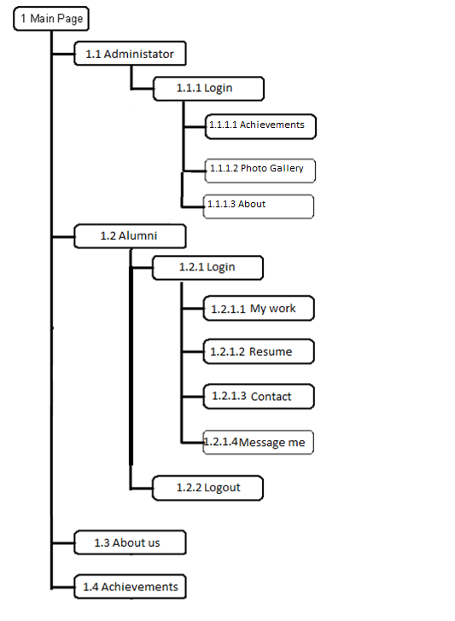

IMPLEMENTATION

1. HOMEPAGE:



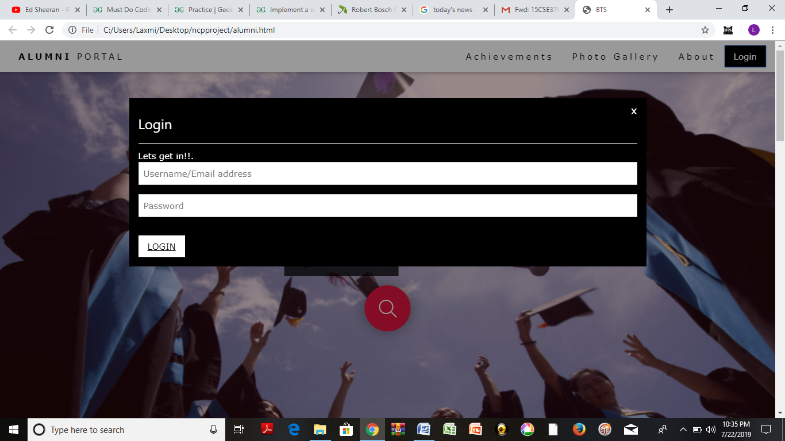

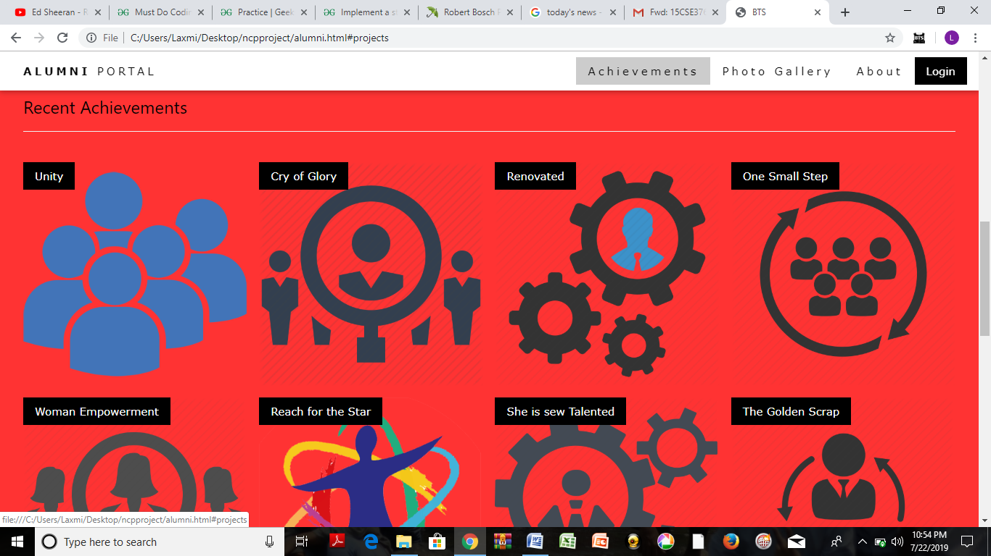

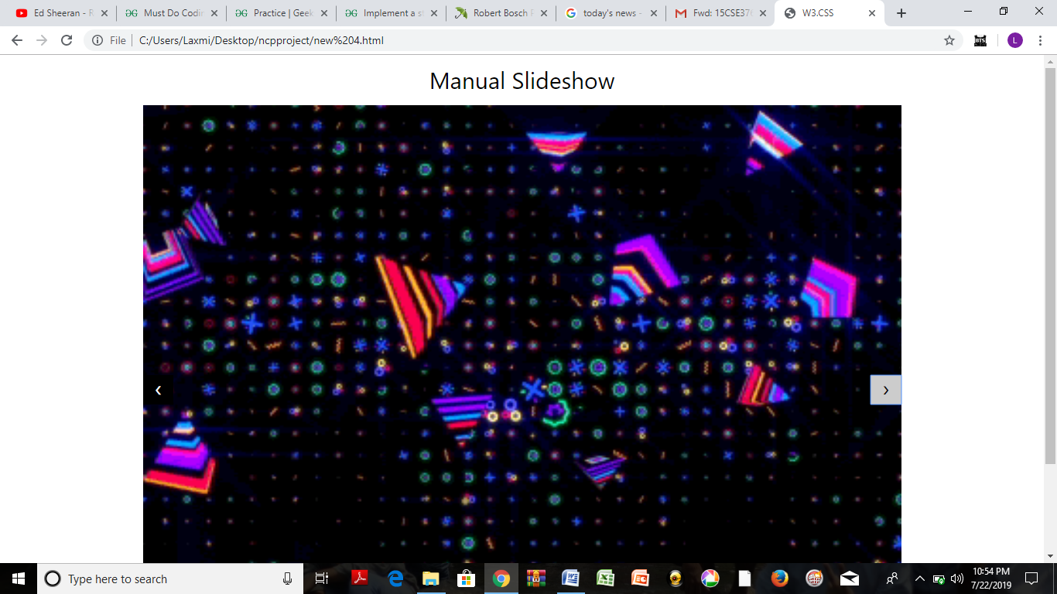

* The homepage displays the login for both Admin and Alumni as well their recent achievements and meritorious alumni. It also displays the photos of recent events which has taken place.
* If you click the Login button, it will show a pop-up asking for Username/Email Id and Password as shown above.
* After you have logged in, you will see a tab menu saying “Welcome back –Your name-- , indicating that you have successfully logged in. It will be displayed as shown below.

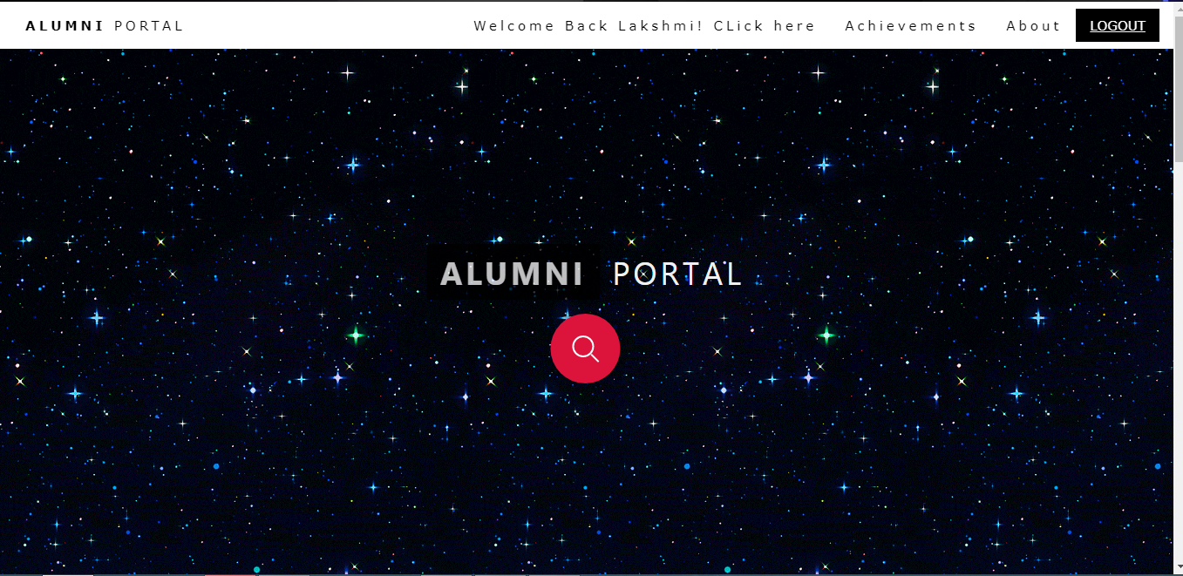

* If you click “Click Here” button in the menu bar. It will take you to your profile as shown below.

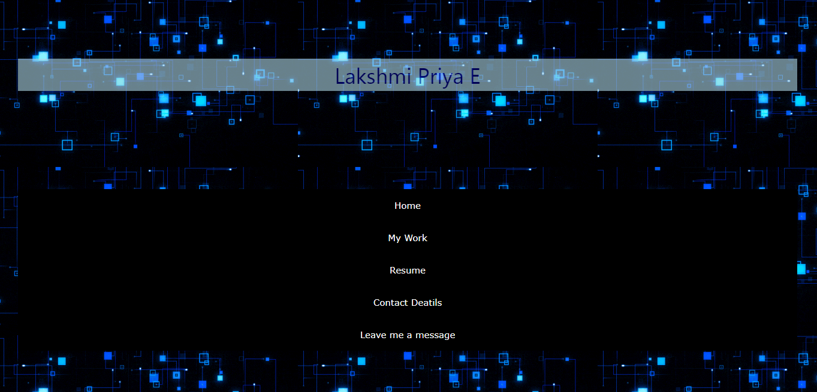

* Then you will be able to see the following sub-menus such as: My work, Resume, Contact Details and Leave me a message.

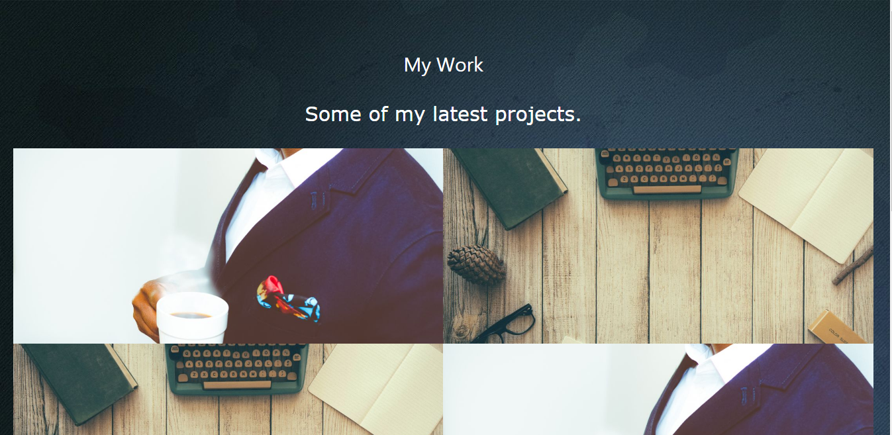

* In “My Work” Space, you will be able to see the alumni’s recent project work images.

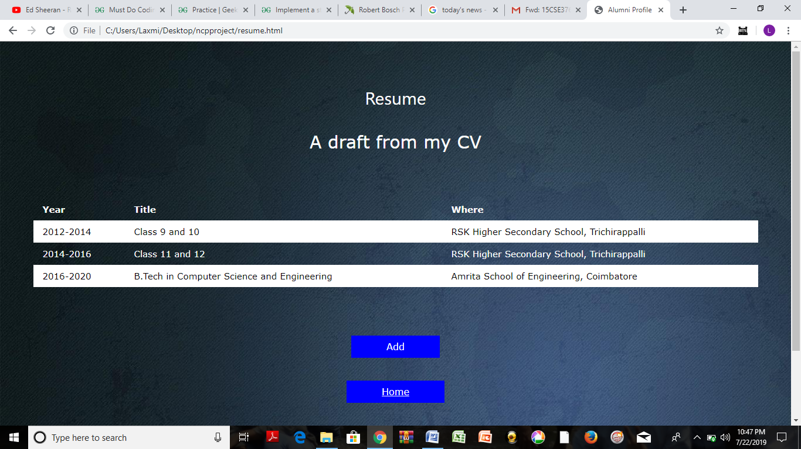

* In “Resume” space, you will be able to see the Alumni’s resume including his education qualification, Work Experience etc.

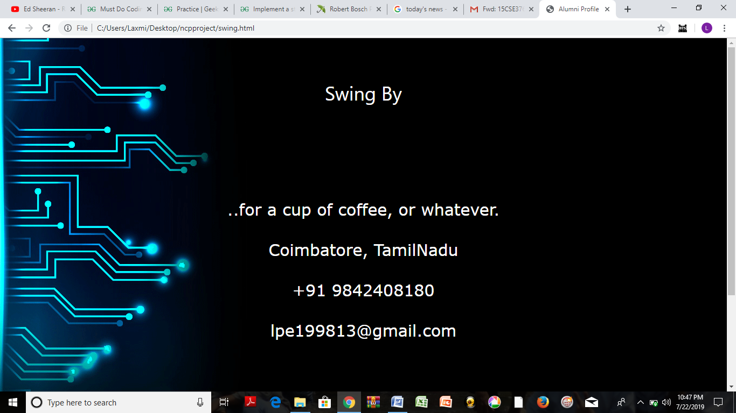

* In “Contact” space, you will be able to get alumni’s phone number and email address.

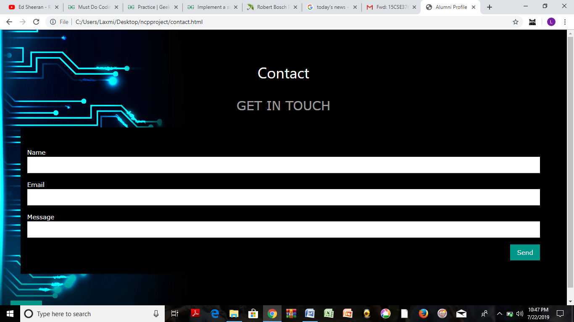

* In “Leave me a message” space, you will be able to leave an alumnus a message mentioning your Name and Email ID.
* In "Admin Login page", administrator can login by using username and password.

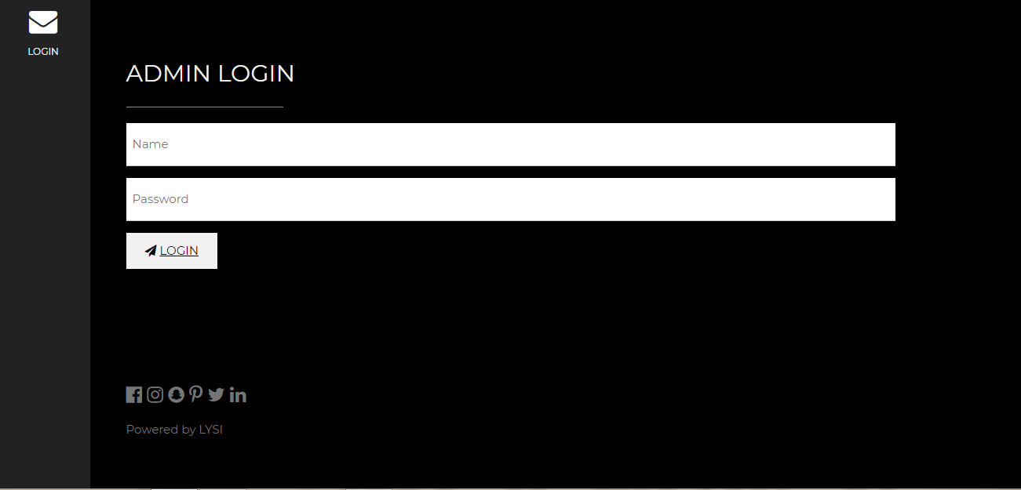

* In this page, we can update the details of achievement ,photos and about page.

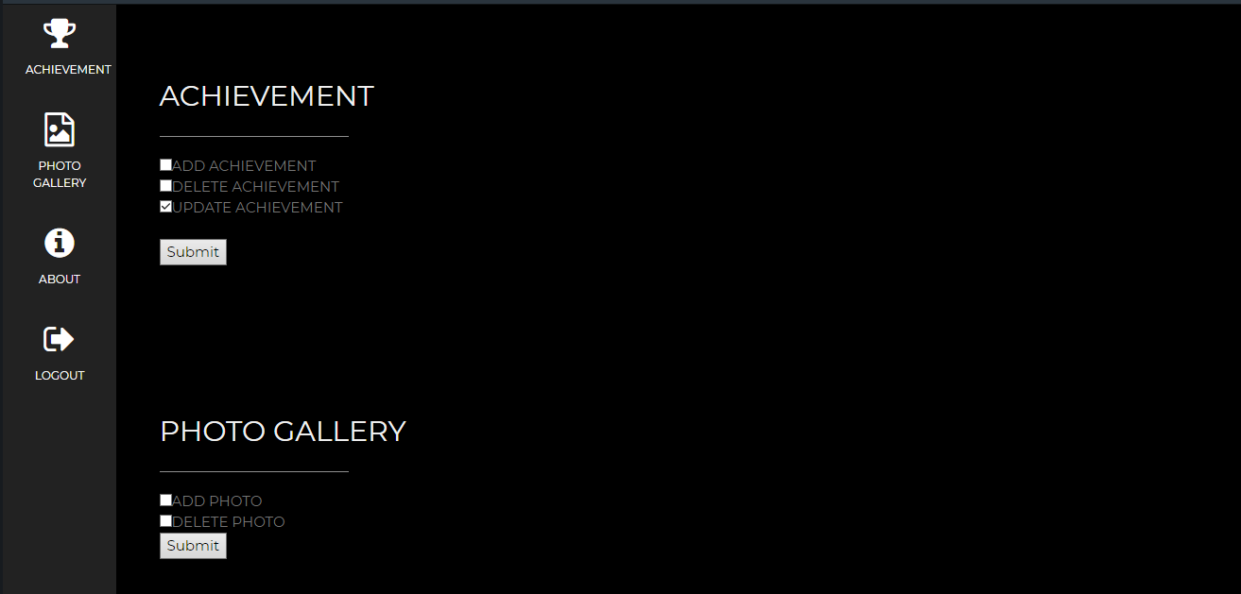

SOURCE CODE: (For Main Page)

<!DOCTYPE html>

<html>

<head>

<title>BTS</title>

<meta charset="UTF-8">

<meta name="viewport" content="width=device-width, initial-scale=1">

<link rel="stylesheet" href="external1.css">

<link rel="stylesheet" href="style.css">

<style>

.mySlides {display:none;}

</style>

</head>

<body>

<!-- Navbar (sit on top) -->

<div class="w3-top">

<div class="w3-bar w3-white w3-wide w3-padding w3-card">

<a href="#home" class="w3-bar-item w3-button"><b>ALUMNI</b> PORTAL</a>

<div class="w3-right w3-hide-small">

<!-- Float links to the right. Hide them on small screens -->

<a href="#projects" class="w3-bar-item w3-button">Achievements</a>

<a href="new 4.html" class="w3-bar-item w3-button">Photo Gallery</a>

<a href="#about" class="w3-bar-item w3-button">About</a>

<!--<a href="#contact" class="w3-bar-item w3-button">Login</a>-->

<button onclick="document.getElementById('menu').style.display='block'" class="w3-button w3-black">Login</button>

</div>

</div>

</div>

<!--Login-->

<div id="menu" class="w3-modal">

<div class="w3-modal-content w3-animate-zoom">

<div class="w3-container w3-black w3-display-container">

<span onclick="document.getElementById('menu').style.display='none'" class="w3-button w3-display-topright w3-large">x</span>

<h3 class="w3-border-bottom w3-border-light-grey w3-padding-16">Login</h3>

<p>Lets get in!!.</p>

<form action="/action_page.php" target="_blank">

<input class="w3-input w3-border" type="text" placeholder="Username/Email address" required name="Name">

<input class="w3-input w3-section w3-border" type="password" placeholder="Password" required name="Email">

<button class="w3-button w3-white w3-section" type="submit">

<i class="fa fa-paper-plane"></i><a href="afterlogin.html"> LOGIN </a>

</button>

</form>

</div>

</div>

</div>

<!-- Header -->

<header class="w3-display-container w3-content w3-wide" style="max-width:1400px;" id="home">

<img class="mySlides w3-animate-fading " src="image1.png" alt="Architecture" width="1400" height="900">

<img class="mySlides w3-animate-fading" src="image2.jpg" alt="Architecture" width="1400" height="900">

<img class="mySlides w3-animate-fading" src="image3.jpg" alt="Architecture" width="1400" height="900">

<img class="mySlides w3-animate-fading" src="image4.jpg" alt="Architecture" width="1400" height="900">

<div class="w3-display-middle w3-margin-top w3-center">

<h1 class="w3-xxlarge w3-text-white"><span class="w3-padding w3-black w3-opacity-min"><b>ALUMNI</b></span> <span class="w3-hide-small w3-text-light-grey">PORTAL</span></h1>

<br><br><br><br>

<br><br><br><br>

<div class="container">

<input type="text" placeholder="Search...">

<div class="search"></div>

</div>

</div>

</header>

<script>

var slideIndex = 1;

showDivs(slideIndex);

function plusDivs(n) {

showDivs(slideIndex += n);

}

function showDivs(n) {

var i;

var x = document.getElementsByClassName("mySlides");

if (n > x.length) {slideIndex = 1}

if (n < 1) {slideIndex = x.length}

for (i = 0; i < x.length; i++) {

x[i].style.display = "none";

}

x[slideIndex-1].style.display = "block";

}

</script>

<!-- Page content -->

<div class="w3-content w3-padding" style="max-width:1564px">

<!-- Project Section -->

<div class="w3-container w3-padding-32" id="projects">

<h3 class="w3-border-bottom w3-border-light-grey w3-padding-16">Recent Achievements</h3>

</div>

<div class="w3-row-padding">

<div class="w3-col l3 m6 w3-margin-bottom">

<div class="w3-display-container">

<div class="w3-display-topleft w3-black w3-padding">Unity</div>

<img src="4.png" alt="House" style="width:100%">

</div>

</div>

<div class="w3-col l3 m6 w3-margin-bottom">

<div class="w3-display-container">

<div class="w3-display-topleft w3-black w3-padding">Cry of Glory</div>

<img src="6.png" alt="House" style="width:100%">

</div>

</div>

<div class="w3-col l3 m6 w3-margin-bottom">

<div class="w3-display-container">

<div class="w3-display-topleft w3-black w3-padding">Renovated</div>

<img src="7.png" alt="House" style="width:100%">

</div>

</div>

<div class="w3-col l3 m6 w3-margin-bottom">

<div class="w3-display-container">

<div class="w3-display-topleft w3-black w3-padding">One Small Step</div>

<img src="8.png" alt="House" style="width:100%">

</div>

</div>

</div>

<div class="w3-row-padding">

<div class="w3-col l3 m6 w3-margin-bottom">

<div class="w3-display-container">

<div class="w3-display-topleft w3-black w3-padding">Woman Empowerment</div>

<img src="9.png" alt="House" style="width:99%">

</div>

</div>

<div class="w3-col l3 m6 w3-margin-bottom">

<div class="w3-display-container">

<div class="w3-display-topleft w3-black w3-padding">Reach for the Star</div>

<img src="10.png" alt="House" style="width:99%">

</div>

</div>

<div class="w3-col l3 m6 w3-margin-bottom">

<div class="w3-display-container">

<div class="w3-display-topleft w3-black w3-padding">She is sew Talented</div>

<img src="12.png" alt="House" style="width:99%">

</div>

</div>

<div class="w3-col l3 m6 w3-margin-bottom">

<div class="w3-display-container">

<div class="w3-display-topleft w3-black w3-padding">The Golden Scrap</div>

<img src="15.png" alt="House" style="width:99%">

</div>

</div>

</div>

…….

EVALUATION SHEET

|  |  |  |  |
| --- | --- | --- | --- |
| Roll No | Technology | Max Marks | Marks Awarded |
| CSE16423 | HTML  CSS  JS  VIVA | 10  10  10  10 |  |
| CSE16432  CSE16466  CSE16467 | HTML  CSS  JS  VIVA  HTML  CSS  JS  VIVA  HTML  CSS  JS  VIVA | 10  10  10  10  10  10  10  10  10  10  10  10 |  |
|  | DOCUMENTATION  TOTAL | 10  50 |  |